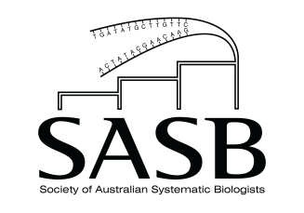

SASB Policy for Twitter Communication

PURPOSE

The social media platform Twitter is becomingly an increasingly useful and important platform for promoting and disseminating scientific research.

The SASB Executive has decided to begin using Twitter as another means of communication, in addition to the Society’s website, Facebook page and membership emails.

The purpose of the SASB Twitter account will be:
- to promote publications and research by financial members of the Society; and
- to promote other material which is relevant to the Society, such as science news, media releases, information regarding the Decadal Plan, articles in The Conversation, etc.

In this way the Twitter account will provide financial members with another outlet for promoting their work more broadly.

HOW IT WILL WORK

Financial members of the SASB can send potential tweets to the Society email address (SASBiologists@gmail.com). The Secretary (refer to https://www.sasb.org.au/contact) will then assemble the tweet and post it on behalf of the Society. If a tweet is deemed potentially controversial, out of scope or not within the best interests of the SASB, it will be run past the President, and then past the Council if necessary.

When sending a tweet to the Secretary a member should include:
- A short written summary (280 character limit);
- A link to the article or relevant material;
- An image if one is available;
- Any twitter handles (usernames) they want to be included in the tweet.

Members are encouraged to send in a tweet for new publications, as well as any other relevant material they would like the Society to promote.

Members can also help by tagging the SASB’s Twitter page in their own relevant tweets (@SASBiologists), and re-tweeting posts by the Society.

The SASB Twitter page will follow members, as well as other scientists broadly relevant to the field of biosystematics. This will be at the discretion of the Secretary, who will consult with the President/Council if required.

The SASB Twitter page will also re-tweet material of general relevance to the field of biosystematics, with an emphasis on re-tweeting appropriate material tweeted by members. This will be at the discretion of the Secretary, who will consult the President/Council if required.

The SASB Twitter page will not tweet or re-tweet material deemed offensive, discriminatory or otherwise contrary to the SASB Code of Conduct (refer to https://www.sasb.org.au/harassment-and-safety-policy).

For further details please contact the SASB Secretary (refer to https://www.sasb.org.au/contact):
Email: SASBiologists@gmail.com

